Lab 1: Horrendograms, Tuesday Lake Food Web

Jonah Bacon

Introduction

Tuesday Lake is a lake in the Upper Peninsula of Michigan, part of a collection of lakes used to study long-term ecological questions in north temperature lakes. The lake is located on land part of the University of Notre Dame Environmental Research Center, the National Ecological Observatory Network (NEON), and the North Temperate Lakes US Long-Term Ecological Research Network. This lake is largely free of anthropogenic pressures, which has leant the lake well as a canvas upon which to conduct whole-lake level experiments and to understand ecosystems apart from human impacts.

Due to the lack of significant human impacts to Tuesday Lake, this lake’s ecosystem offers a great opportunity to study a natural food web. In 1984 and 1986, the Tuesday Lake food web was sampled. This included estimating the number and biomass for every member of the community as well as determining which species were consumed by which predators.

Methods

The Tuesday Lake food web was explored using R (version 4.1.3) and the *cheddar* package. The *cheddar* package was downloaded from a GitHub repository ([www.github.com/quicklizard99/cheddar](http://www.github.com/quicklizard99/cheddar)) using the *devtools* package. Data was loaded and then explored. Four functions were used to explore the dynamics of the food web: NumberOfNodes to determine the number of species in the food web, NumberOfTrophicLinks to determine the number of trophic connections within the food web, PlotWebByLevel to plot the horrendogram, and PlotNPS to plot the altonian pyramid.

Results

In 1984 and 1986, there were 56 individual species identified within the Tuesday Lake food web. There were 269 distinct trophic (predator-prey) connections between those species. It was unclear how many trophic levels truly existed within the food web (Fig 1), but I classify the system as having five trophic levels. Though the top levels don’t end up as classified as truly distinct 4th and 5th trophic levels, it is clear that these levels are different from the 3rd level due to the nature of their trophic connections. The lowest level contains the greatest number of species and the proportion of species decreases with each successive level (Fig 1).

The relationship between biomass and trophic level is generally inconclusive (Fig 2), with a couple of outlier species having very high abundance. Many species have a very low biomass. Ignoring outlier species with high biomass, biomass tends to decrease as trophic level increases.

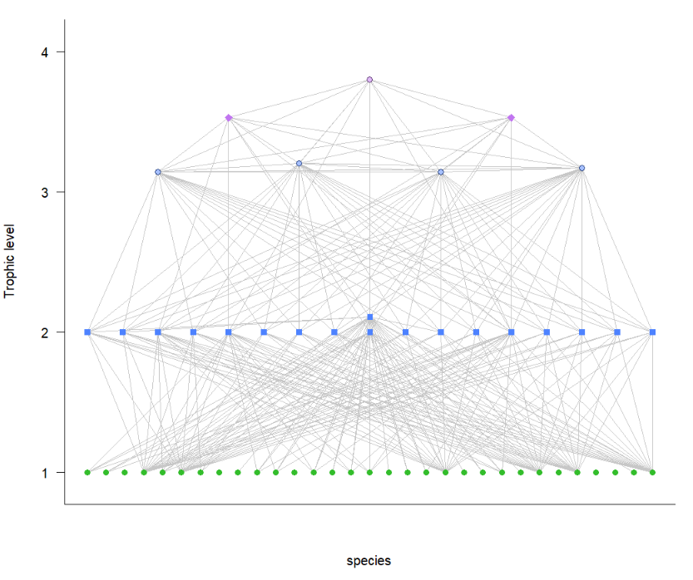

Figure 1 Horrendogram diagram of the Tuesday Lake food web in 1984. Each shape object represents a different species. Lines represent trophic interactions between two species.

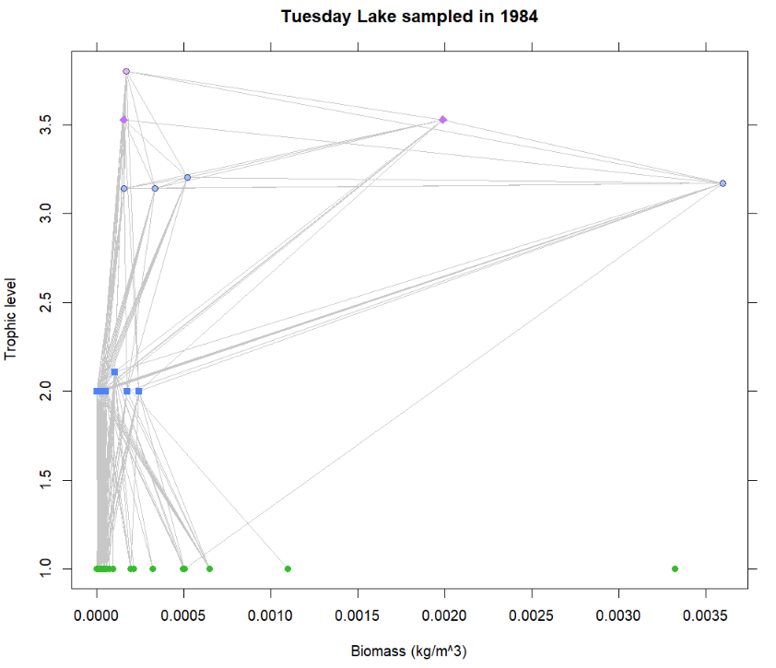

Figure 2 Altonian pyramid of the Tuesday Lake food web in 1984. Each shape object represents a different species and each line represents trophic interactions between two species. The biomass (kg/m^3) is plotted against the estimated trophic position of each species.

Discussion

Exploring the Tuesday Lake food web reveals large insights into aquatic trophic ecology. First, there are many more trophic linkages than there are species, indicating that the vast majority of predator species rely upon multiple prey and the vast majority of prey species are predated by multiple predators. By visualizing the number of trophic links to each species, it can be seen that a couple species are immensely important. Amongst primary consumers (trophic level 2), the couple of species located near the vertical center line of Fig 1 have many links to the level 1 primary producers. This indicates they’re generalist foragers an perhaps indicates their importance to the food web. Likewise, six primary producers have a large number of interactions with higher trophic levels, indicating their importance as prey to a broad suite of consumers. There does appear to be some separation between the level 3 consumers and two higher levels. These higher level 4 and level 5 consumers may be important consumers of level 3 and level 4 consumers, respectively.

From visualizing the altonian pyramid (Fig 2), a couple of key species are revealed. These species are important due to their high biomass, especially relative to their trophic level. It was expected that as trophic level increased, biomass would decrease. For one species in TL3 and one species in TL4, this was not the case as they both had relatively high biomasses for their trophic level. And in general, the third trophic level had relatively high biomass as compared to some of the lower levels. I would have liked to have figured out how to combine all of the biomass within a trophic level to look at how total biomass within each level compares. One interesting thing to note is that the most abundant primary producer showed zero connections with higher trophic levels.